Notice of rent increase to tenant/s of rented premises

***Residential Tenancies Act 1997* (the Act) Section 44**

**Residential Tenancies Regulations 2008, Regulation 20**

**Warning:** Enter text in spaces provided only. This form will be invalid if you remove or change any questions or other text.

**Use this form for giving notice to tenant/s of a rent increase**

Please note:

* You can only use this form to notify of one rent increase at a time.
* Landlords cannot increase rent more often than once every six months.

# How to use this form

## Complete parts 1 to 7

You must complete all boxes.

## Complete part 8

Write in the new rent amount and the date on which the rent increase will start (date must be at least 60 days from the date of this notice).

## Sign part 9 and write your name at part 10

## When the form is complete

Tear out the top two forms (Tenant’s copies) and send both to the tenant.

Keep the last copy of the form for your records.

# How to serve this notice

**You can serve this notice by hand, ordinary post or registered post to the tenant**

If you send a notice by ordinary or registered post, you must take into account the extra days it takes for the notice to be given. For ordinary post this usually means at least one business day after the notice was posted. For registered post this usually means at least two business days after the notice was posted.

If you need help with this notice, call the Consumer Affairs Victoria Helpline on 1300 55 81 81 or visit [consumer.vic.gov.au/renting](http://www.consumer.vic.gov.au/renting)

# Telephone Interpreter Service

If you have difficulty understanding English, contact the Translating and Interpreting Service (TIS) on 131 450 (for the cost of a local call) and ask to be put through to an Information Officer at Consumer Affairs Victoria on 1300 55 81 81.

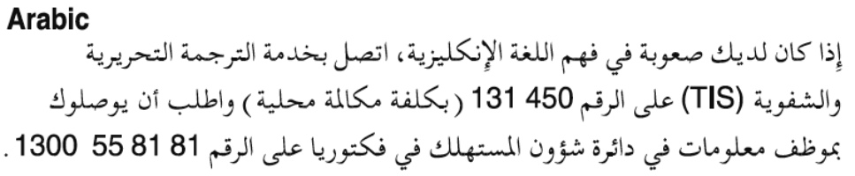

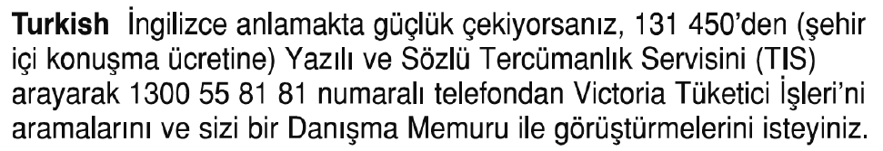





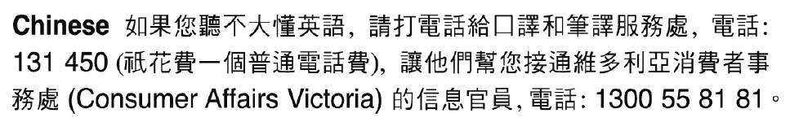

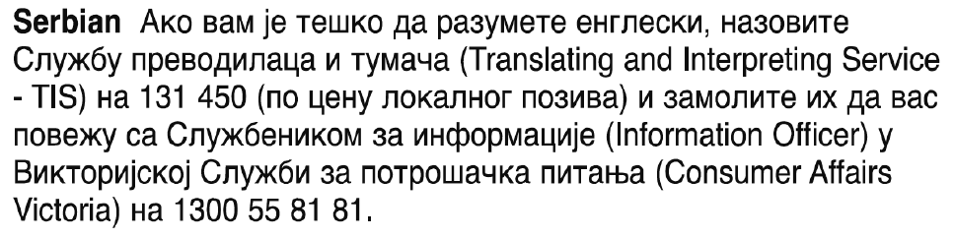



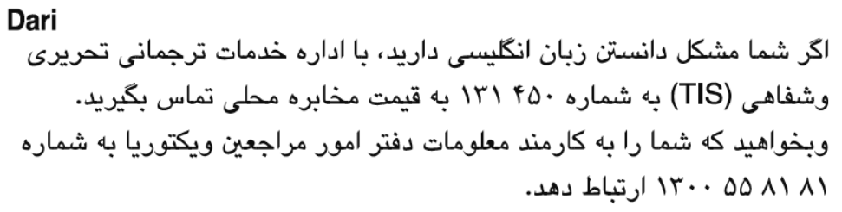



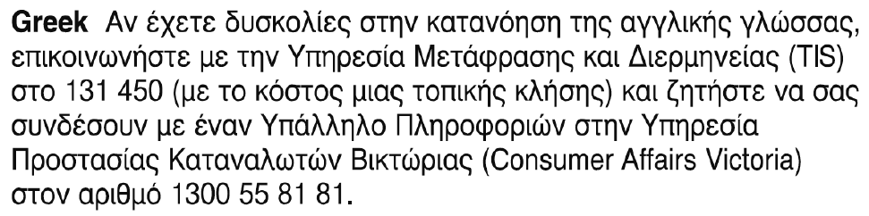

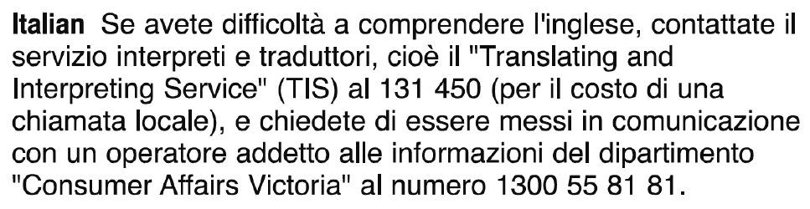

Notice of rent increase to tenant/s of rented premises From the landlord

***Residential Tenancies Act 1997* (the Act) Section 44 Tenant’s copy**

**Residential Tenancies Regulations 2008, Regulation 20**

# Tenant details

1. This notice is given to: *(tenant/s names)*

|  |
| --- |
|  |

1. Regarding the rented premises at: *(write address)*

|  |
| --- |
|  |

1. Tenant/s address: *(if same address as 2, write ‘as above’)*

|  |
| --- |
| As above |

# Landlord details

1. Name of landlord (of the rented premises):   
   *(insert name of landlord, cannot be an agent’s name)*

|  |
| --- |
|  |

1. Address of landlord (of the rented premises) for the purpose of serving documents: (*can be an agent’s address)*

|  |
| --- |
|  |

1. Contact telephone numbers (of landlord or agent):

|  |  |
| --- | --- |
| Business hours: |  |
| After hours: | ( ) |

# Service details

1. This notice is given to the tenant: *(mark one method only)*

|  |  |
| --- | --- |
| by hand: |  |
| by registered post: |  |
| by ordinary post: |  |
| on this date: |  |

# Rent increase amount and start date

1. I am giving you at least 60 days notice that I propose to increase the rent.

|  |  |
| --- | --- |
| The current rent is ($): |  |
| The new rent is ($):  *(new rent amount)* |  |
| and will commence on: *(start date)* | / / |

1. Signature of landlord or agent:

|  |
| --- |
|  |

1. Name of landlord or agent signing this notice:   
   *(include name of estate agency where applicable)*

|  |
| --- |
|  |

1. If you consider this proposed rent increase is excessive, you can apply to the Director of Consumer Affairs Victoria within 30 days after this notice is given to investigate and report on the proposed rent, under section 45 of the *Residential Tenancies Act 1997.*

**Tenants note:** Excessive rent is determined according to the accepted market rental value of the premises.

1. The landlord cannot increase your rent more often than once every 6 months.
2. Under a fixed term tenancy agreement, a landlord must not increase the rent before the fixed term ends unless the agreement specifically provides for an increase.
3. If you need help with this notice, you can call the Consumer Affairs Victoria Helpline on 1300 55 81 81 or visit [consumer.vic.gov.au/renting](http://www.consumer.vic.gov.au/renting)

# Rent increase investigation (no cost) *(note: this section is not part of the notice)*

If you want to request an investigation, it must be in writing. You can apply for an investigation, by ticking the box below, writing your daytime telephone number, and posting a copy of this form to Director of Consumer Affairs Victoria, GPO Box 123 Melbourne 3001, or fax to 8684 6310, or email to [renting@justice.vic.gov.au](mailto:renting@consumer.vic.gov.au). After your request has been received, a Residential Tenancies Inspector will contact you.

|  |  |
| --- | --- |
| Yes, I/we the tenant/s wish to apply for a rent increase investigation: |  |
| Tenant/s daytime telephone number: |  |

***Privacy*** *– Consumer Affairs Victoria (CAV) is bound by laws that protect your privacy concerning the collection, use and disclosure of your personal information. If you request a rent increase investigation, CAV will use the address and telephone details you have given on this form to contact you about carrying out the investigation, as we are required to do under section 45 of the Residential Tenancies Act 1997. If you confirm that you wish the investigation to proceed, a copy of the written rent assessment report will be given to both you and your landlord.*

Notice of rent increase to tenant/s of rented premises From the landlord

***Residential Tenancies Act 1997* (the Act) Section 44 Tenant’s copy**

**Residential Tenancies Regulations 2008, Regulation 20**

# Tenant details

1. This notice is given to: *(tenant/s names)*

|  |
| --- |
|  |

1. Regarding the rented premises at: *(write address)*

|  |
| --- |
|  |

1. Tenant/s address: *(if same address as 2, write ‘as above’)*

|  |
| --- |
| As above |

# Landlord details

1. Name of landlord (of the rented premises):   
   *(insert name of landlord, cannot be an agent’s name)*

|  |
| --- |
|  |

1. Address of landlord (of the rented premises) for the purpose of serving documents: (*can be an agent’s address)*

|  |
| --- |
|  |

1. Contact telephone numbers (of landlord or agent):

|  |  |
| --- | --- |
| Business hours: |  |
| After hours: | ( ) |

# Service details

1. This notice is given to the tenant: *(mark one method only)*

|  |  |
| --- | --- |
| by hand: |  |
| by registered post: |  |
| by ordinary post: |  |
| on this date: |  |

# Rent increase amount and start date

1. I am giving you at least 60 days notice that I propose to increase the rent.

|  |  |
| --- | --- |
| The current rent is ($): |  |
| The new rent is ($):  *(new rent amount)* |  |
| and will commence on: *(start date)* | / / |

1. Signature of landlord or agent:

|  |
| --- |
|  |

1. Name of landlord or agent signing this notice:   
   *(include name of estate agency where applicable)*

|  |
| --- |
|  |

1. If you consider this proposed rent increase is excessive, you can apply to the Director of Consumer Affairs Victoria within 30 days after this notice is given to investigate and report on the proposed rent, under section 45 of the *Residential Tenancies Act 1997.*

**Tenants note:** Excessive rent is determined according to the accepted market rental value of the premises.

1. The landlord cannot increase your rent more often than once every 6 months.
2. Under a fixed term tenancy agreement, a landlord must not increase the rent before the fixed term ends unless the agreement specifically provides for an increase.
3. If you need help with this notice, you can call the Consumer Affairs Victoria Helpline on 1300 55 81 81 or visit [consumer.vic.gov.au/renting](http://www.consumer.vic.gov.au/renting)

# Rent increase investigation (no cost) *(note: this section is not part of the notice)*

If you want to request an investigation, it must be in writing. You can apply for an investigation, by ticking the box below, writing your daytime telephone number, and posting a copy of this form to Director of Consumer Affairs Victoria, GPO Box 123 Melbourne 3001, or fax to 8684 6310, or email to [renting@justice.vic.gov.au](mailto:renting@consumer.vic.gov.au). After your request has been received, a Residential Tenancies Inspector will contact you.

|  |  |
| --- | --- |
| Yes, I/we the tenant/s wish to apply for a rent increase investigation: |  |
| Tenant/s daytime telephone number: |  |

***Privacy*** *– Consumer Affairs Victoria (CAV) is bound by laws that protect your privacy concerning the collection, use and disclosure of your personal information. If you request a rent increase investigation, CAV will use the address and telephone details you have given on this form to contact you about carrying out the investigation, as we are required to do under section 45 of the Residential Tenancies Act 1997. If you confirm that you wish the investigation to proceed, a copy of the written rent assessment report will be given to both you and your landlord.*

Notice of rent increase to tenant/s of rented premises From the landlord

***Residential Tenancies Act 1997* (the Act) Section 44 Landlord’s copy**

**Residential Tenancies Regulations 2008, Regulation 20**

# Tenant details

1. This notice is given to: *(tenant/s names)*

|  |
| --- |
|  |

1. Regarding the rented premises at: *(write address)*

|  |
| --- |
|  |

1. Tenant/s address: *(if same address as 2, write ‘as above’)*

|  |
| --- |
| As above |

# Landlord details

1. Name of landlord (of the rented premises):   
   *(insert name of landlord, cannot be an agent’s name)*

|  |
| --- |
|  |

1. Address of landlord (of the rented premises) for the purpose of serving documents: (*can be an agent’s address)*

|  |
| --- |
|  |

1. Contact telephone numbers (of landlord or agent):

|  |  |
| --- | --- |
| Business hours: |  |
| After hours: | ( ) |

# Service details

1. This notice is given to the tenant: *(mark one method only)*

|  |  |
| --- | --- |
| by hand: |  |
| by registered post: |  |
| by ordinary post: |  |
| on this date: |  |

# Rent increase amount and start date

1. I am giving you at least 60 days notice that I propose to increase the rent.

|  |  |
| --- | --- |
| The current rent is ($): |  |
| The new rent is ($):  *(new rent amount)* |  |
| and will commence on: *(start date)* | / / |

1. Signature of landlord or agent:

|  |
| --- |
|  |

1. Name of landlord or agent signing this notice:   
   *(include name of estate agency where applicable)*

|  |
| --- |
| «TenancyManager» |

1. If you consider this proposed rent increase is excessive, you can apply to the Director of Consumer Affairs Victoria within 30 days after this notice is given to investigate and report on the proposed rent, under section 45 of the *Residential Tenancies Act 1997.*

**Tenants note:** Excessive rent is determined according to the accepted market rental value of the premises.

1. The landlord cannot increase your rent more often than once every 6 months.
2. Under a fixed term tenancy agreement, a landlord must not increase the rent before the fixed term ends unless the agreement specifically provides for an increase.
3. If you need help with this notice, you can call the Consumer Affairs Victoria Helpline on 1300 55 81 81 or visit [consumer.vic.gov.au/renting](http://www.consumer.vic.gov.au/renting)

# Rent increase investigation (no cost) *(note: this section is not part of the notice)*

If you want to request an investigation, it must be in writing. You can apply for an investigation, by ticking the box below, writing your daytime telephone number, and posting a copy of this form to Director of Consumer Affairs Victoria, GPO Box 123 Melbourne 3001, or fax to 8684 6310, or email to [renting@justice.vic.gov.au](mailto:renting@consumer.vic.gov.au). After your request has been received, a Residential Tenancies Inspector will contact you.

|  |  |
| --- | --- |
| Yes, I/we the tenant/s wish to apply for a rent increase investigation: |  |
| Tenant/s daytime telephone number: |  |

***Privacy*** *– Consumer Affairs Victoria (CAV) is bound by laws that protect your privacy concerning the collection, use and disclosure of your personal information. If you request a rent increase investigation, CAV will use the address and telephone details you have given on this form to contact you about carrying out the investigation, as we are required to do under section 45 of the Residential Tenancies Act 1997. If you confirm that you wish the investigation to proceed, a copy of the written rent assessment report will be given to both you and your landlord.*